Name : Zuha Irfan
Roll No : 2023-BSE-073
Subject: Cloud Computing
Semester & Section : V-B
Lab : 08

Task 1 — Create an AWS account and enable UAE (me-central-1)
- task1_open_signup_page.png
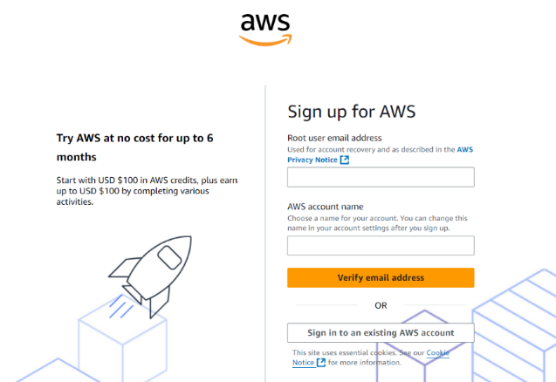

- task1_signed_up_confirmation.png
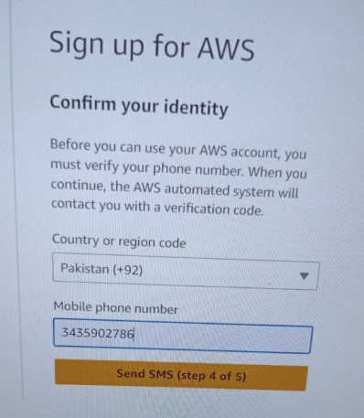

- task1_root_signed_in.png
- task1_enable_region_me-central-1.png

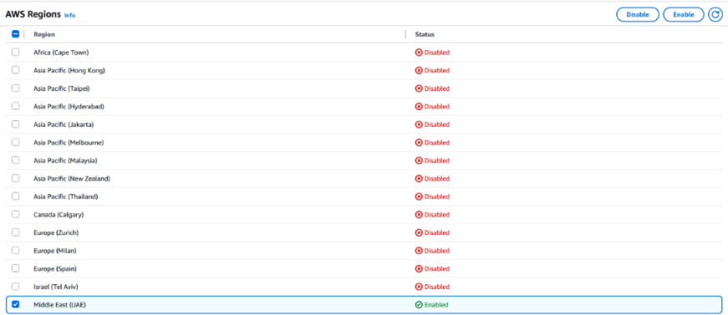
- task1_summary.png

Task 2 — Create IAM Admin and Lab8User with console access
- task2_open_iam_console.png
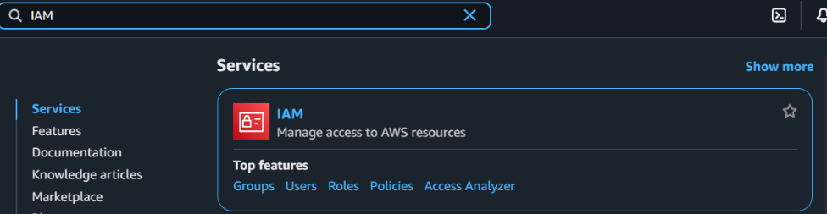

- task2_admin_create_confirmation.png
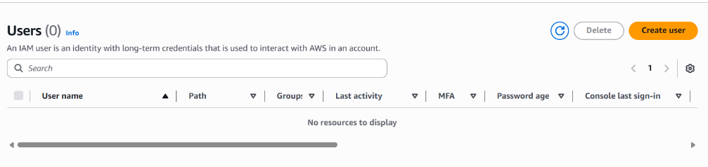

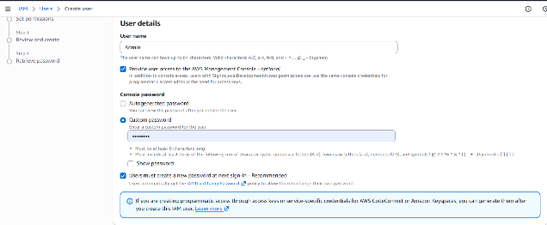

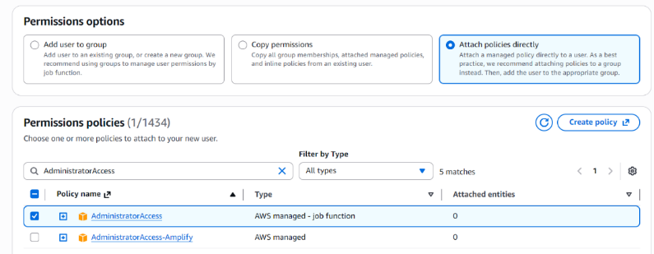
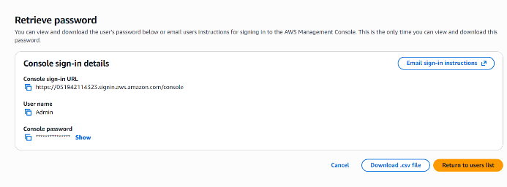
- task2_admin_csv_and_signin_url.png
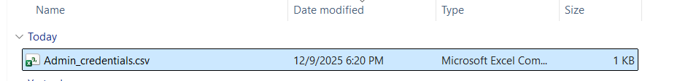

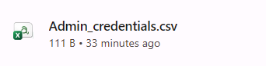
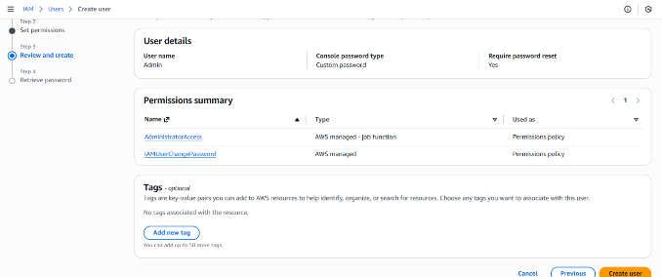

- task2_admin_console_after_login.png

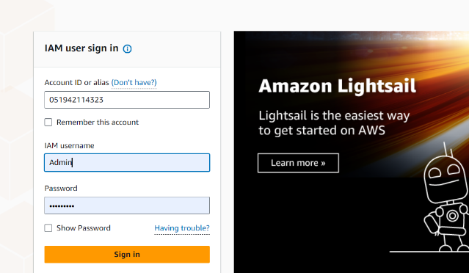

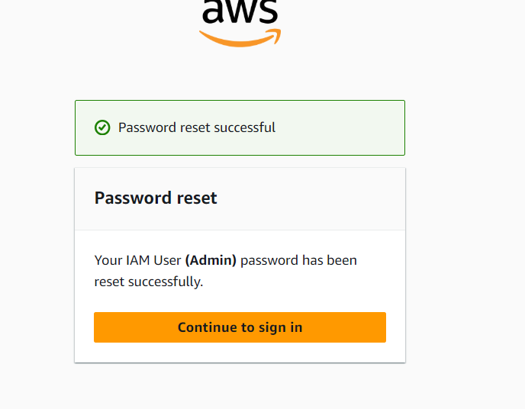

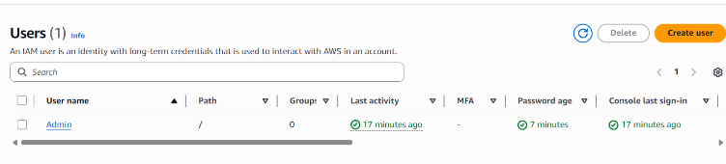

- task2_create_lab8user_and_csv.png
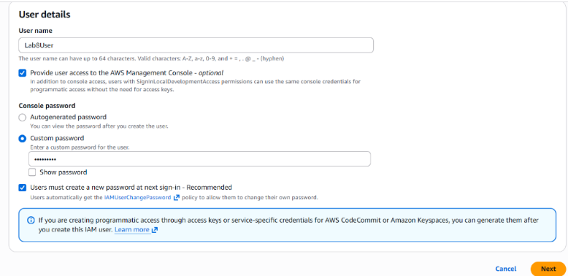

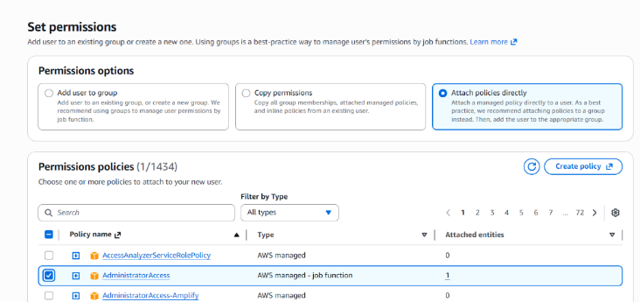

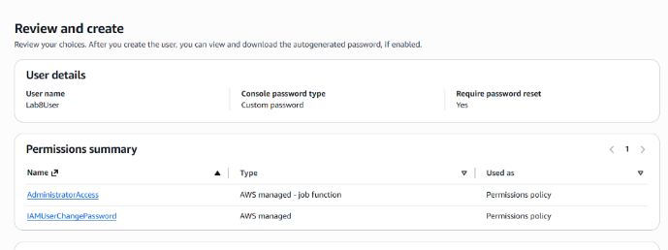

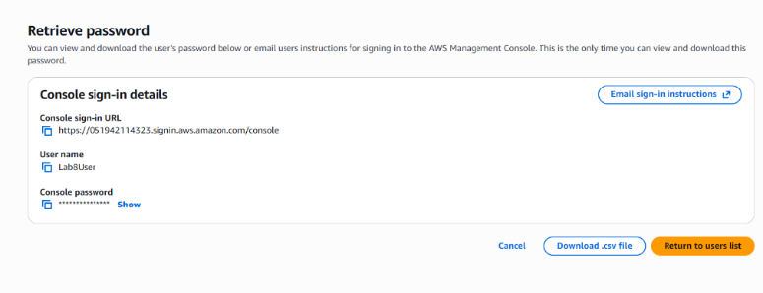

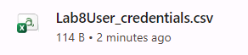
- task2_lab8user_csv_saved.png
- task2_lab8user_logged_in.png
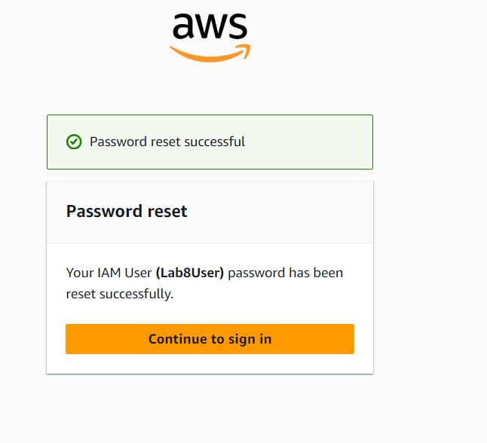

- task2_summary.png
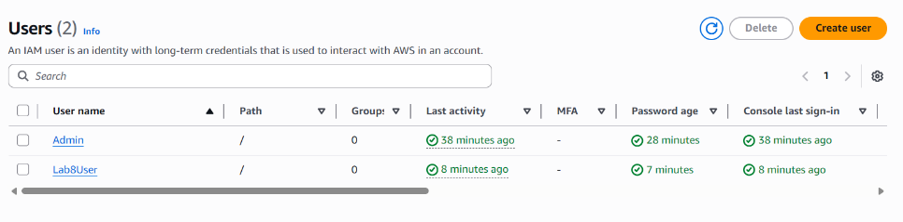

Task 3 — Inspect VPC resources (in UAE me-central-1)
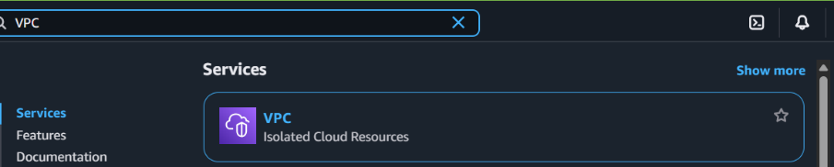
- task3_open_vpc_console.png

- task3_vpcs_list.png
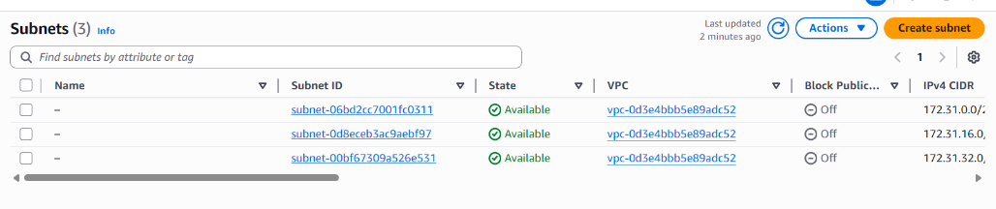

- task3_subnets_list.png
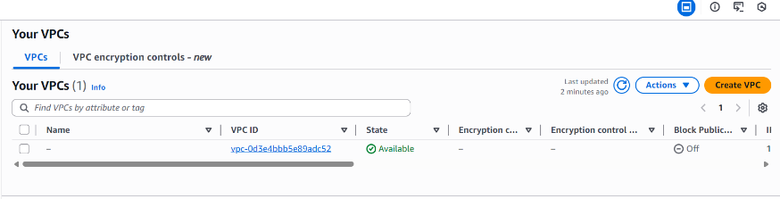

- task3_route_tables_list.png
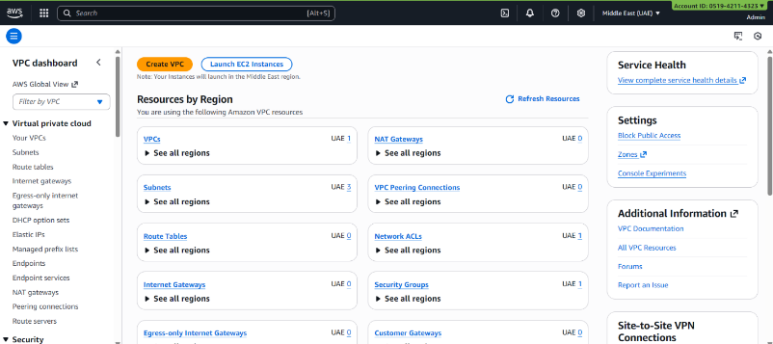
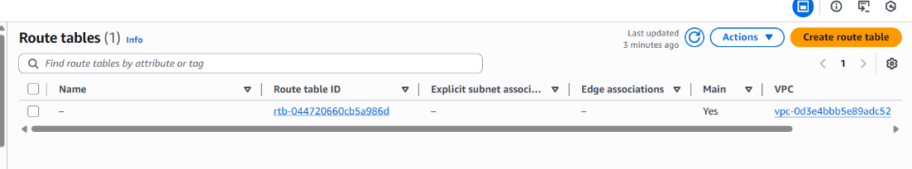
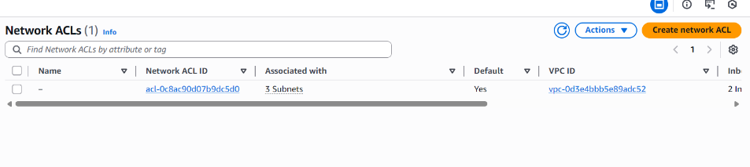
- task3_network_acls_list.png

- task3_summary.png
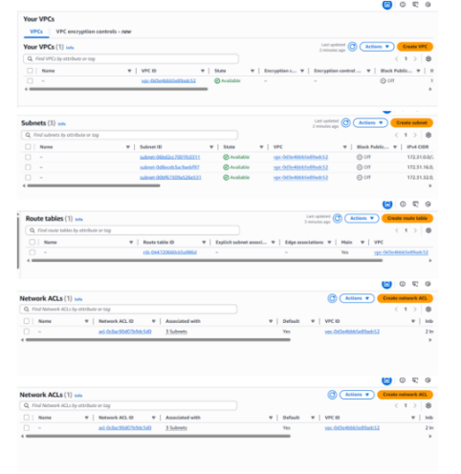

Task 4 — Launch EC2, SSH, install Docker & Docker Compose, deploy Gitea
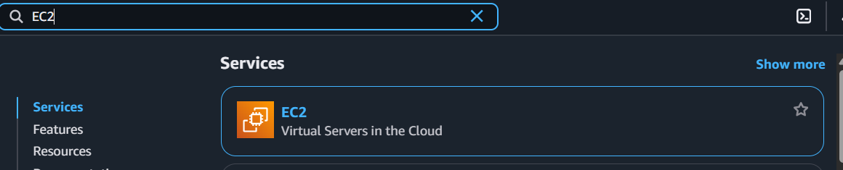
- task4_open_ec2_console.png

- task4_launch_instance_config.png
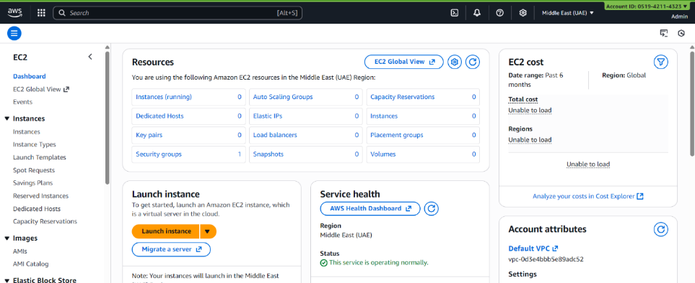

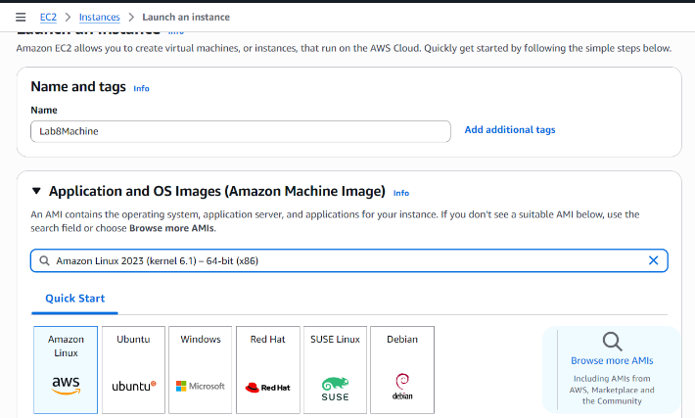

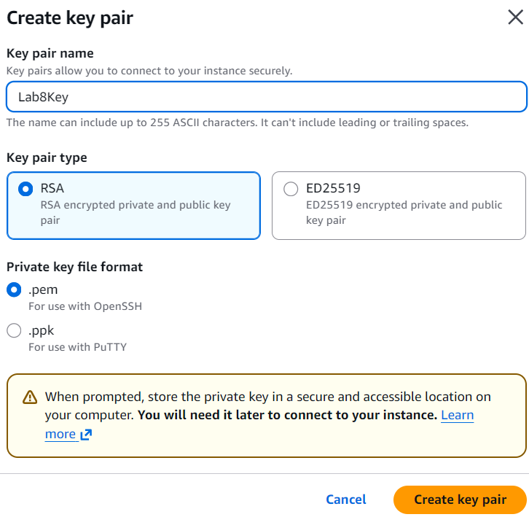

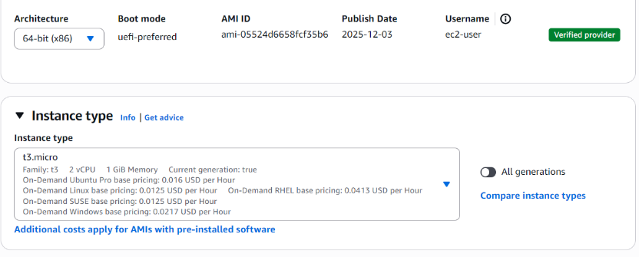
- task4_keypair_download.png


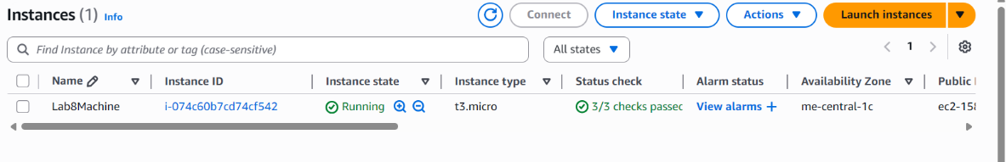
- task4_instance_running_console.png
- task4_ssh_from_windows_to_ec2.png
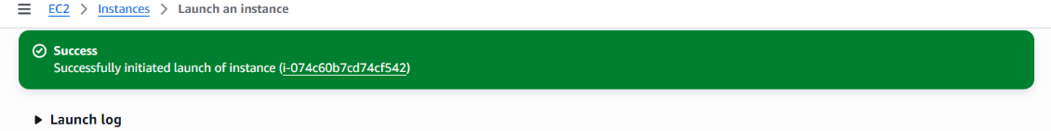
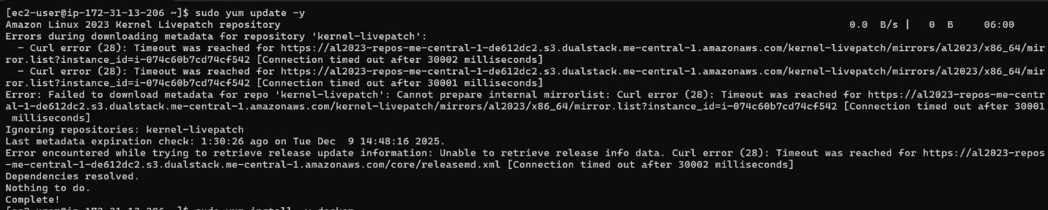
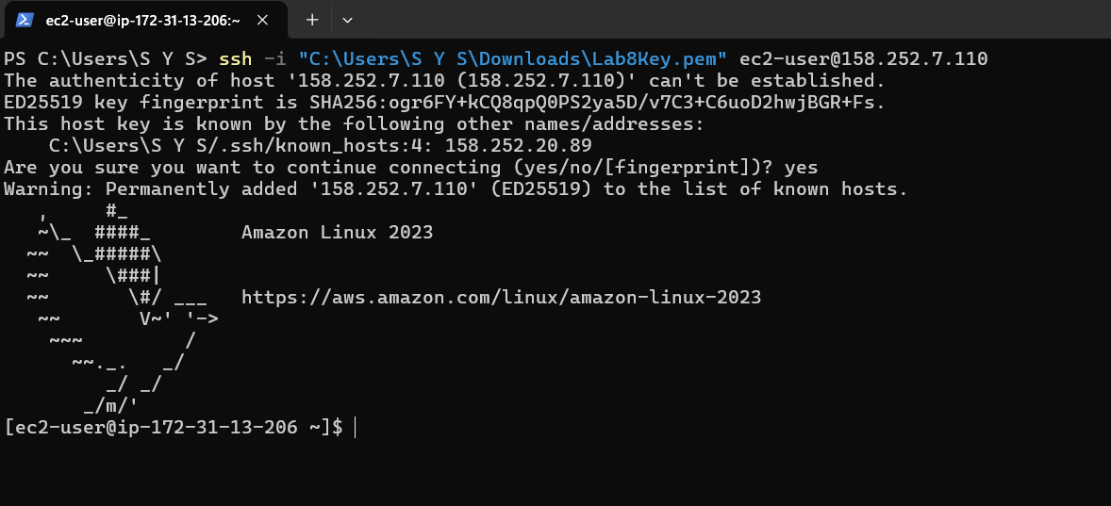
- task4_ec2_install_docker_compose_started.png
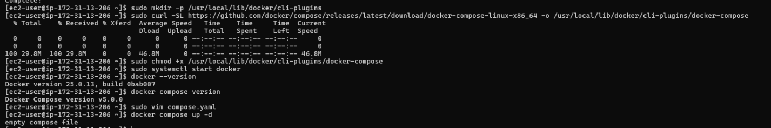

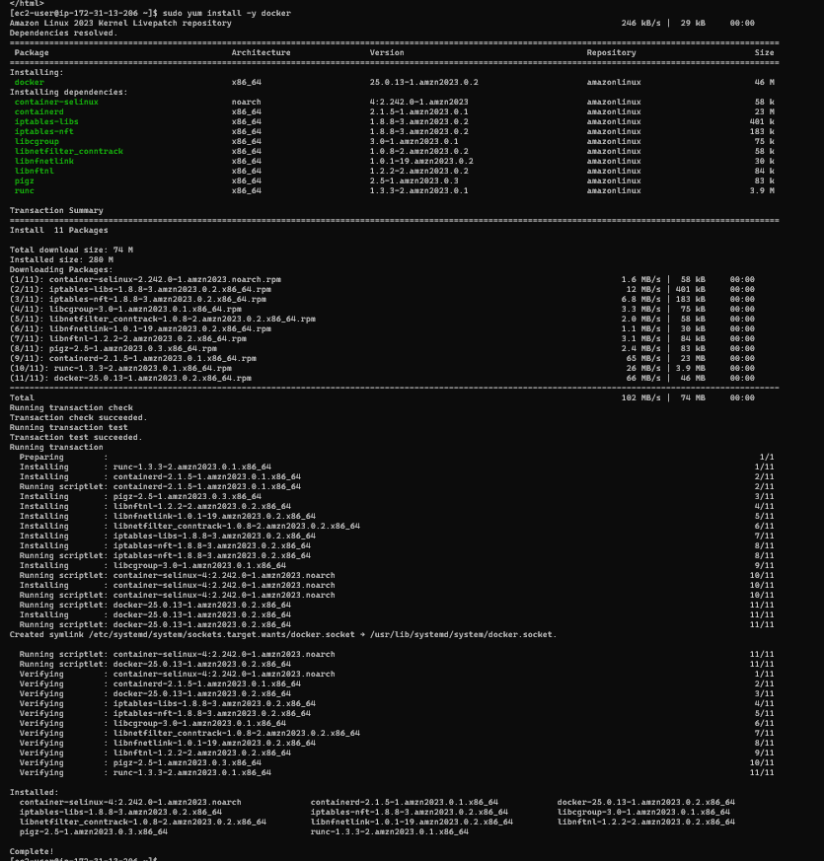
- task4_vim_compose_yaml_paste.png
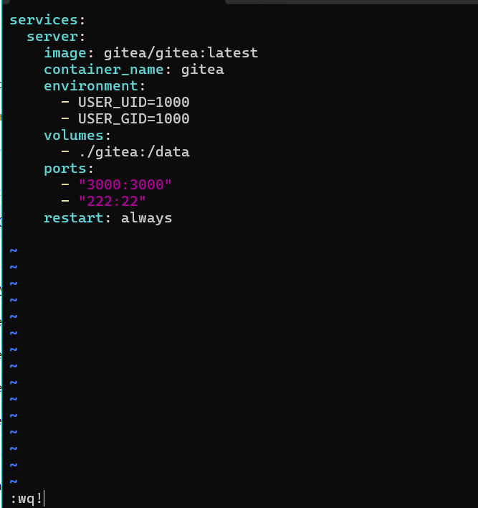

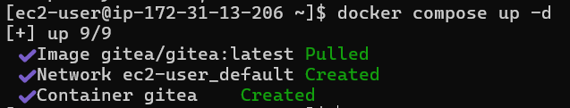

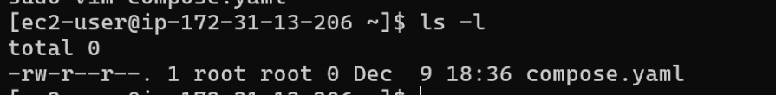
- task4_compose_yaml_saved_ls.png
- task4_usermod_and_groups_before_after.png

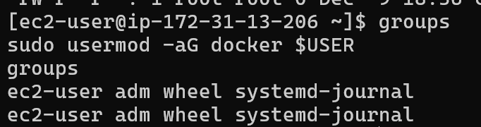

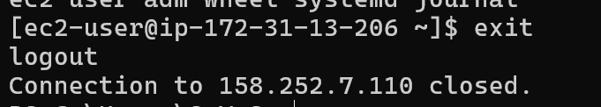

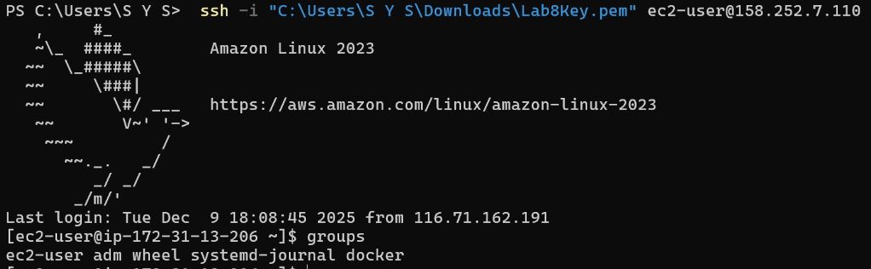

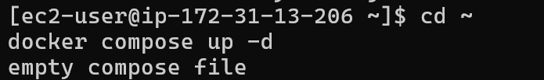
- task4_docker_compose_up.png

- task4_security_group_allow_3000.png
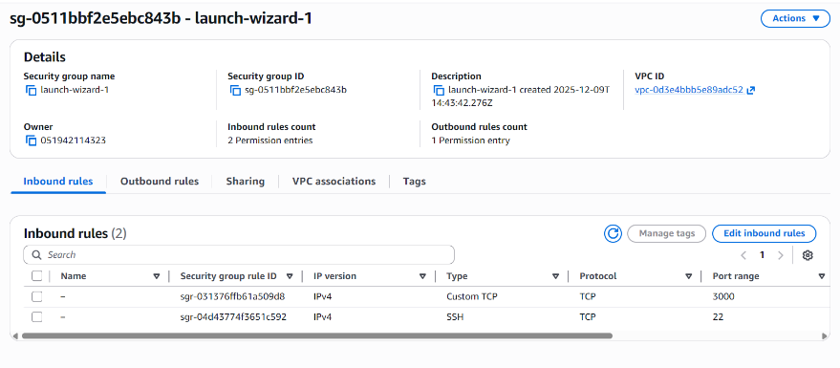
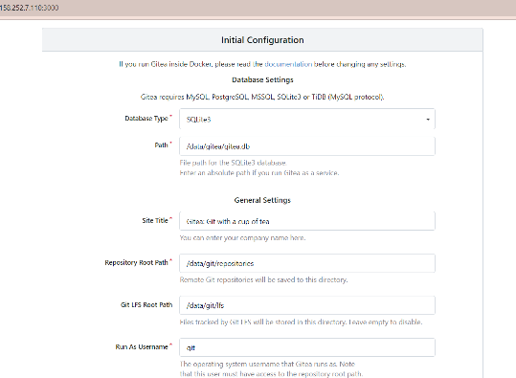
- task4_gitea_install_page.png

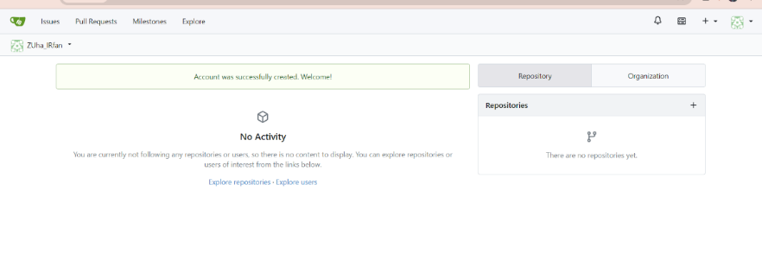

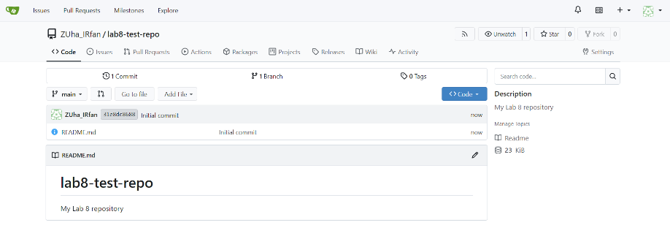
- task4_gitea_create_repo.png
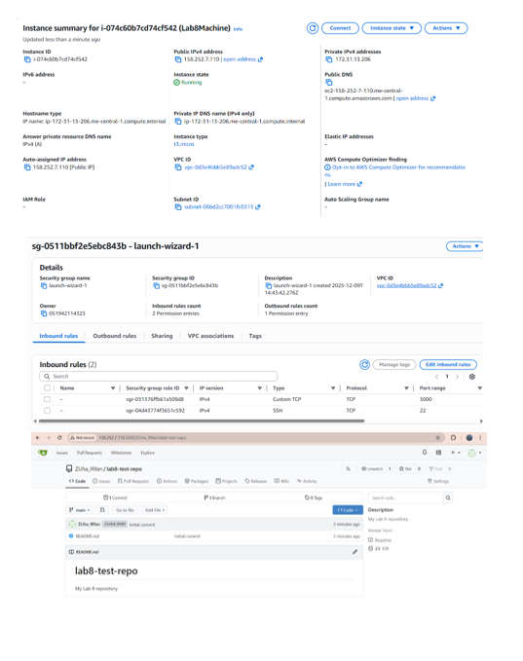
- task4_summary.png

Cleanup — Remove resources to avoid charges
- cleanup_terminate_instance.png
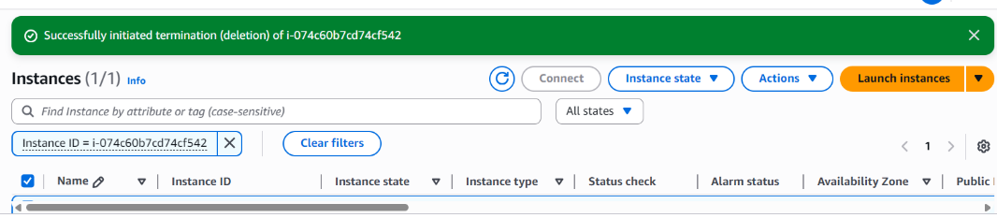
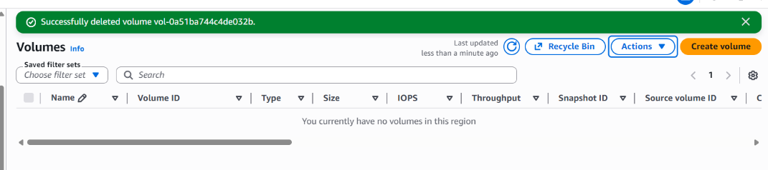
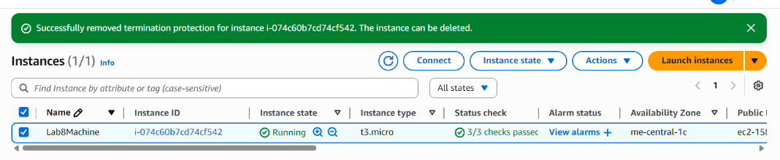
- cleanup_delete_volumes_snapshots.png
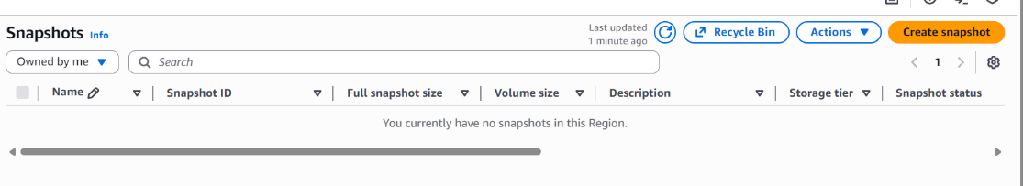
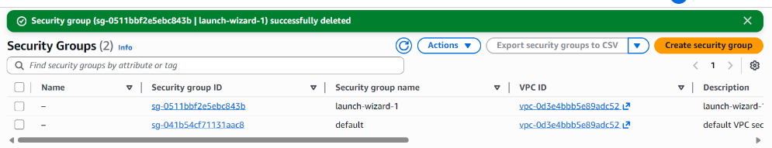
- cleanup_delete_security_group_ and_keypair.png

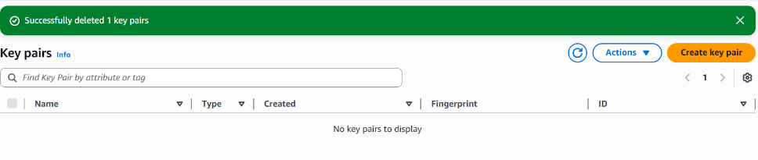
- cleanup_iam_users_deleted.png
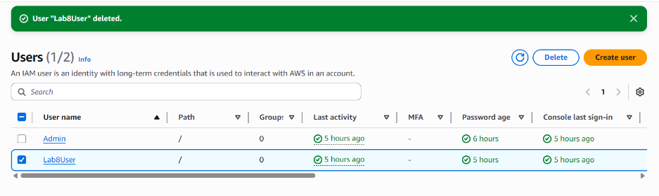
- cleanup_summary.png
